Rialivhuwa Nevhungoni
Practical 2: SQL JOIN



Question 1
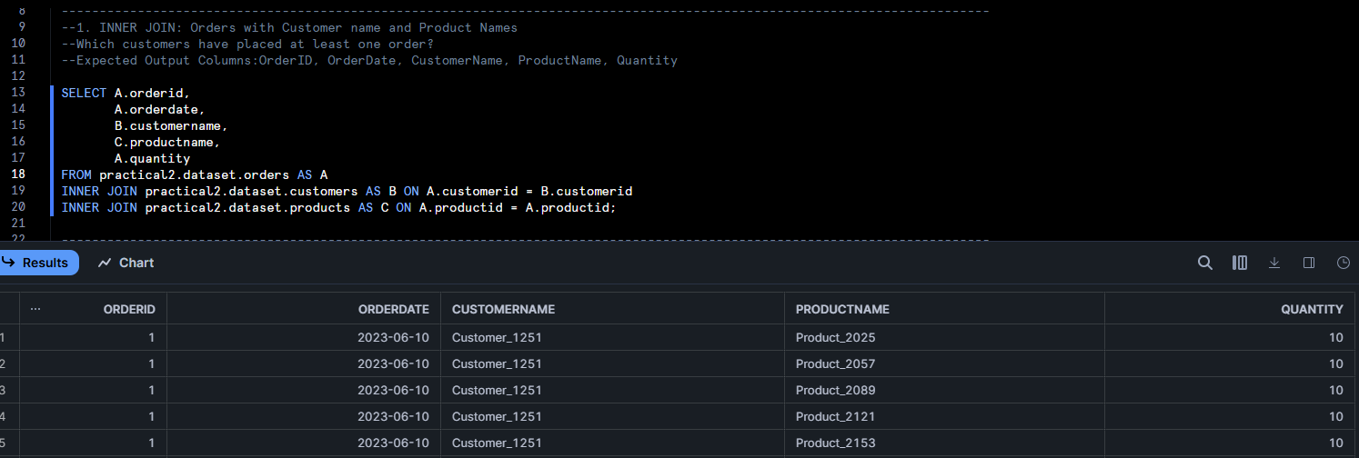

Question 2
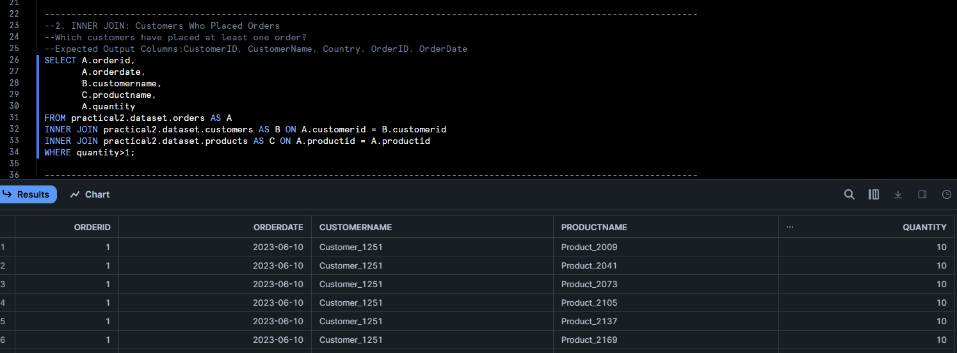

Question 3
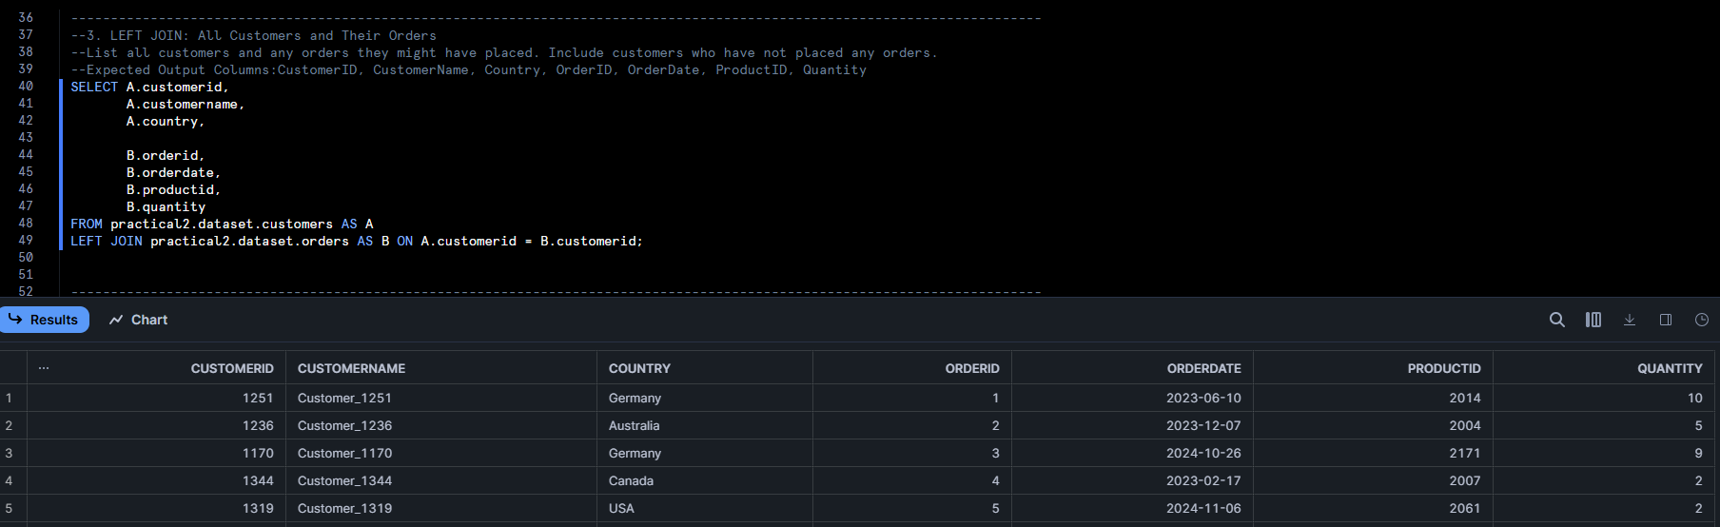

Question 4
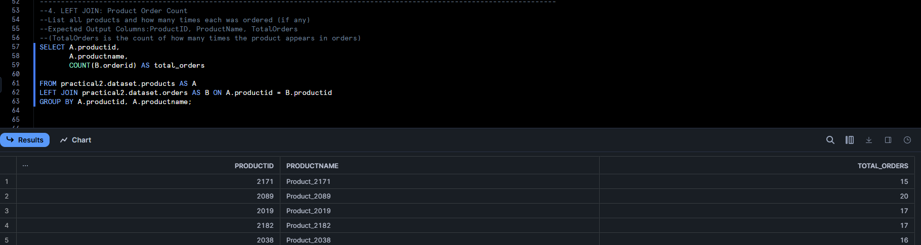

Question 5
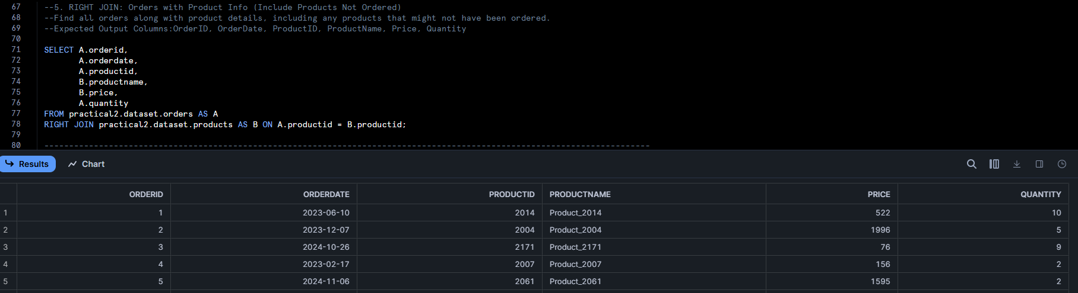
Question 6
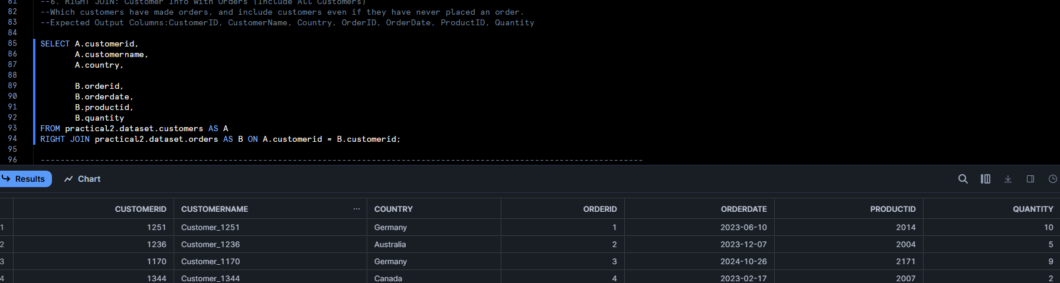

Question 7
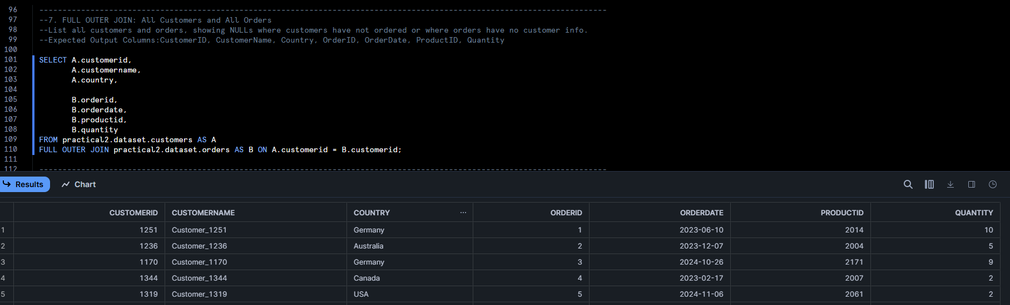

Question 8
